# Experiment 6: Implement Wi-Fi security (WPA2, IP based, MAC Based)

**Step1**: Switch On the D-Link Router.

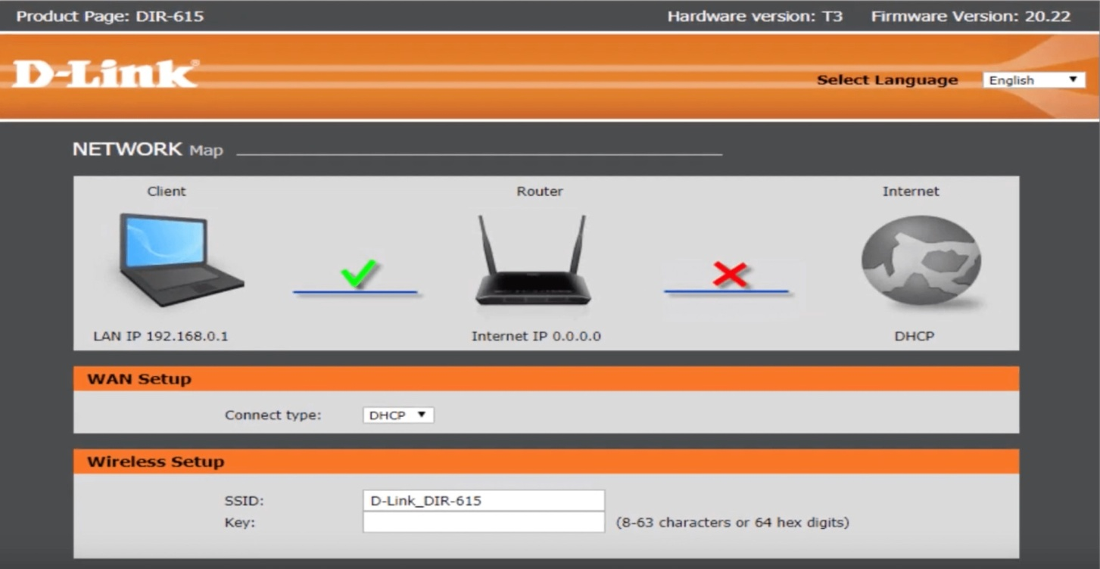Step2: Open a browser and search for dlinkrouter.local

Login

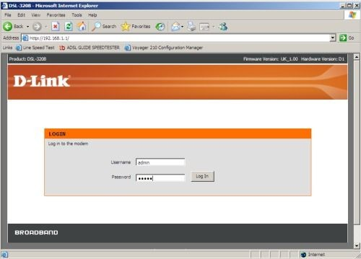

Setup security mode as WPA2

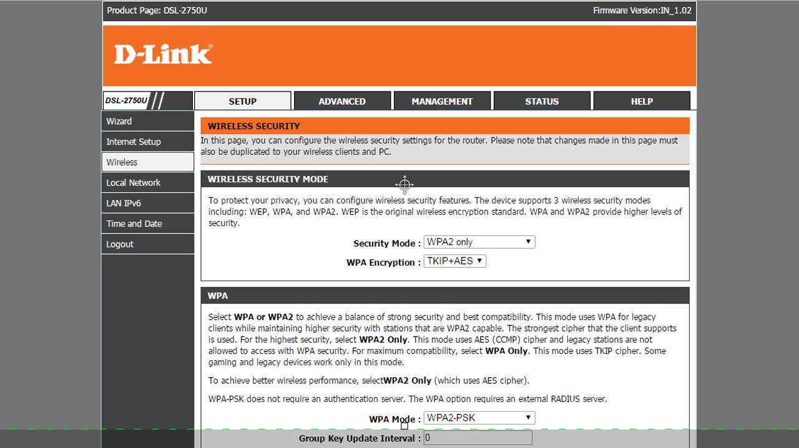

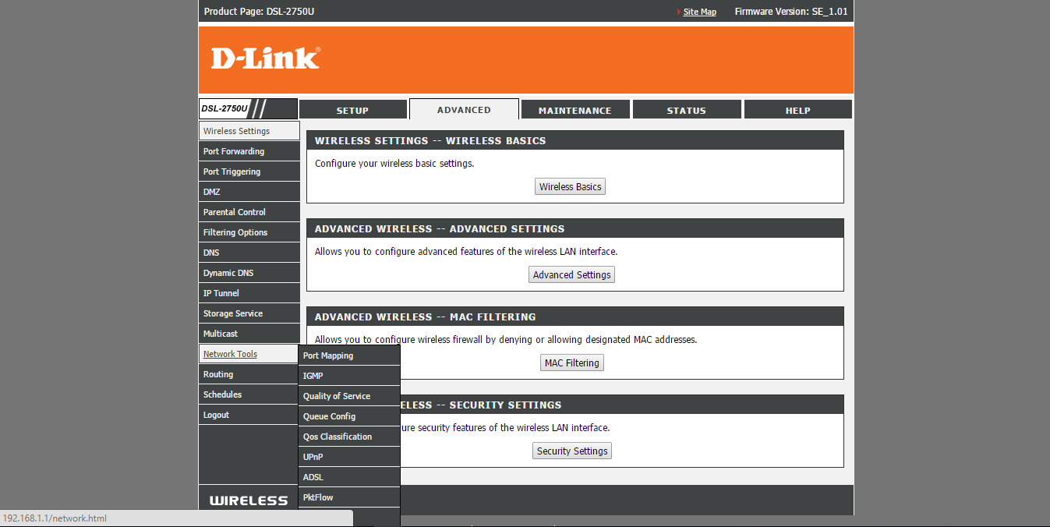Go to advanced tab

Go to wireless tab

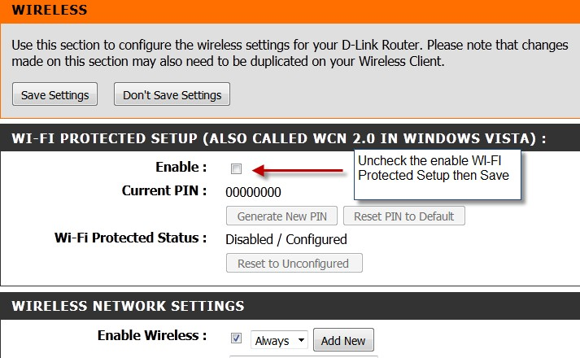

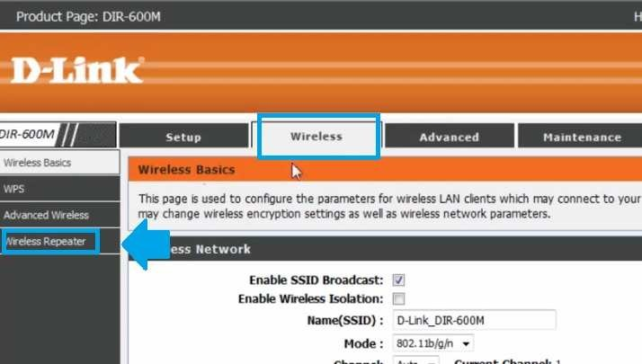Go to wireless Repeater

Goto status tab

